#include <stdio.h>
#include <stdlib.h>
#include <pthread.h>
#include <semaphore.h>
#include <unistd.h>

sem_t s;

void* thread(void* arg)
{

//wait
sem_wait(&s);
printf("\nEntered..\n");

//critical section
sleep(4);

//signal
printf("\nJust Exiting..\n");
sem_post(&s);

}

int main()
{
sem_init(&s,1,3);
pthread_t t1,t2;
pthread_create(&t1,NULL,thread,NULL);
sleep(2);
pthread_create(&t2,NULL,thread,NULL);
pthread_join(t1,NULL);
pthread_join(t2,NULL);
sem_destroy(&s);
return 0;
}
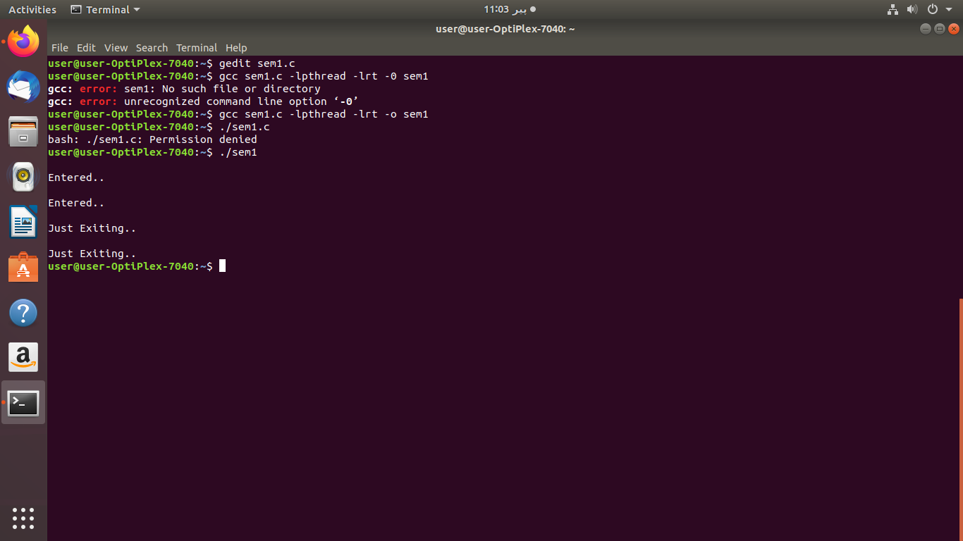
#include <stdio.h>
#include <stdlib.h>
#include <pthread.h>
#include <semaphore.h>
#include <unistd.h>

sem_t s;

void* thread(void* arg)
{

//wait
sem_wait(&s);
printf("\nEntered..\n");

//critical section
sleep(4);

//signal
printf("\nJust Exiting..\n");
sem_post(&s);

}

int main()
{
sem_init(&s,1,3);
pthread_t t1,t2;
pthread_create(&t1,NULL,thread,NULL);
sleep(2);
pthread_create(&t2,NULL,thread,NULL);
pthread_create(&t3,NULL,thread,NULL);
pthread_join(t1,NULL);
pthread_join(t2,NULL);
pthread_join(t3,NULL);
sem_destroy(&s);
return 0;
}
